CLOUD COMPUTING LAB EXPERIMENT
CSA1519 CLOUD COMPUTING AND DATA ANALYTICS
EXPERIMENT 1
1. Create a simple cloud software application for Flight Reservation System using any Cloud Service Provider to demonstrate SaaS

Aim
To design and develop an Airline Reservation System using Zoho Creator that enables passengers to book flights, manage reservation details, and maintain booking records efficiently.

Procedure
- Log in to Zoho Creator.
- Create a new application named Airline Reservation System.
- Create a form and add the required fields such as Passenger Name, Email, Phone Number, Source, Destination, Flight Number, Travel Date, Departure Time, Travel Class, Number of Passengers, Seat Number, Total Fare, Payment Method, and Booking Status.
- Configure dropdown fields with appropriate options (Travel Class, Payment Method, Booking Status, etc.).
- Create reports to display the submitted reservation records.
- Add workflows (optional) to automate calculations such as total fare based on travel class and number of passengers.
- Save and publish the application.
- Test the application by entering sample booking details and verify that the records are stored correctly.

Implementation
The Airline Reservation System was implemented in Zoho Creator using low-code development. A reservation form was created to capture passenger and flight information. Reports were generated to display all booking records. Dropdown menus were used to minimize data entry errors, and workflows were configured to automate calculations such as total fare. The application allows users to submit reservations, while administrators can easily view and manage booking information through reports.
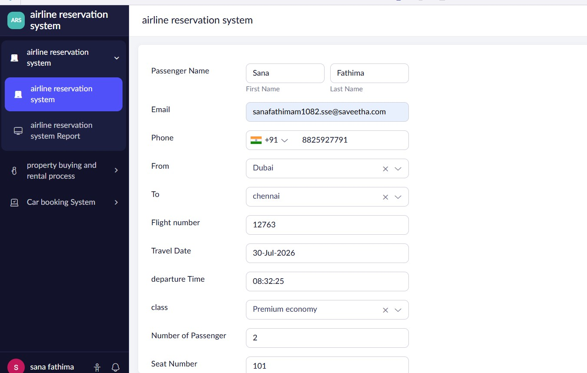
FIGURE 1: AIRLINE RESERVATION FORM
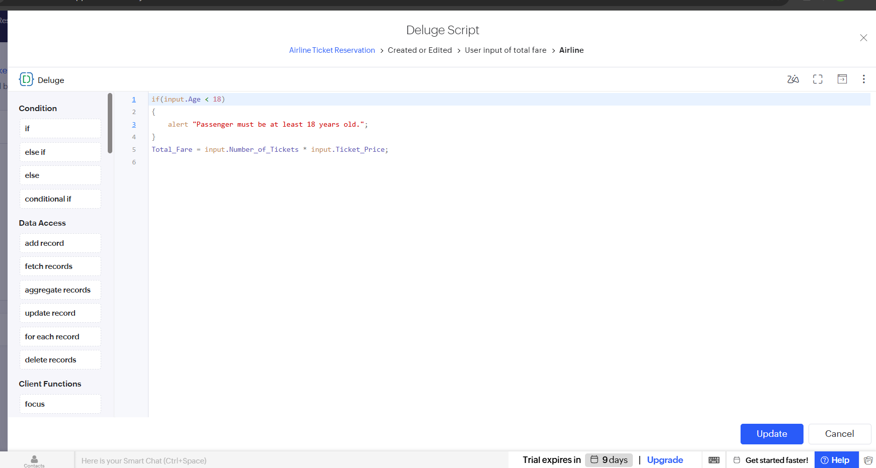
FIGURE 2: WORKFLOW
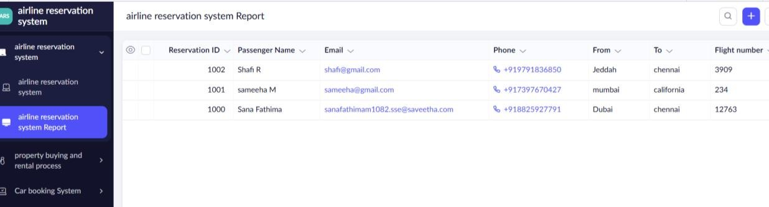
FIGURE 3: AIRLINE RESERVATION REPORT

Result
The Airline Reservation System was successfully developed using Zoho Creator. The application allows users to enter flight reservation details, stores the information securely, generates booking reports, and supports workflow automation, providing a simple and efficient flight booking management system.

